2023-2024 CAA AFTER SCHOOL PROGRAM FAMILY CONTRACT

This contract is made effective as of ____________ by and between the following parties:

“Provider” Croton Academy of Arts (CAA)
8 Old Post Road South, Croton on Hudson, New York 10520
afterschool@crotonacademy.org , (914) 862-0988 \ and

Name: _____________Relationship to child:: ______________

Home Address: ______________City:_Croton on Hudson__ NY Zip _______

Place of Employment: ___________________work number: ___________________

Home Phone Number: ______________________ Cell Phone Number: _____

E-mail: ______________________

To provide care for: Child’s Name: ______________________
(a separate contract and health form must be submitted for each child)

The Undersigned Caregiver(s) hereby gives CAA permission to care for the above child(ren) in accordance with this Contract. In consideration of the mutual agreements and covenants contained in the Contract, the parties agree to the following:

1. CONTRACTED DAYS The Provider shall provide child care services and the Parent/Guardian shall pay for such services as follows:

❑ Monday ❑ Tuesday ❑ Wednesday ❑ Thursday ❑ Friday
This schedule will be in effect unless terminated sooner by either party in accordance with this Contract.
The Parent/Guardian shall pay child fees for the CAA After School program based on the above schedule at the rates specified below. Fees will not be adjusted for late arrival, early pickup, or missed days, except as provided by the Contract. Partial refunds are given on a case by case basis..

2. PROGRAM SCHEDULE

CET 2:30-6:00 pm (grades K-3) 6:30 for late pick up | PVC 3:00-6:00 pm (grades 4-7)

By signing this Contract, the undersigned represents that they understood and agreed to the terms and conditions of this Contract. Breach of this Contract in any way by the Parent/Guardian may result in immediate termination of services.

Parent/Guardian _________________________________

I hereby release the Directors and all employees of Croton Academy of Arts from all claims of liability for any damage or injuries which may be sustained by my child in the After School program or any class at the CHUFSD.

parent/guardian signature ____________________________________________

I hereby give permission for my child’s photograph to be used for program purposes.

parent/guardian signature ________________________________________

Pick up Authorization/ Emergency contact form

CHILD’S NAME ______________________________ ____

AUTHORITY TO PICK UP CHILD The following person(s) has authority to pick up the child(ren)

Name: ___________________________________ Cell number: _____________

Name: ______________________________ Cell number: _________________

Name: __________________________ Cell number: ___________________

The Parent/Guardian shall inform Croton Academy in advance if someone other than the Parent/Guardian or person(s) listed above will pick up the children.

DOES NOT HAVE AUTHORITY TO PICK UP CHILD
The following person(s) does not have authority to pick up the child(ren).

Name: ______________________________________________________________

EMERGENCY CONTACTS In case of emergency, Croton Academy of Arts will first try to reach the Parent/Guardian. CAA will need at least one of the three emergency contacts listed to be local to Croton on Hudson.

1.Name: ___________________________Relationship: ____________
Address: _________________________________________________
City: ____________________________ State: _____ Zip: ________
Cell Number: ______Ok to text _____ Other phone Number: ____________________

2.Name: _____________________________Relationship: __________
Address: _______________________________________________
City: ____________________________________________ State: ____ Zip: ___________
Cell Number: ___________Ok to text _______ Other phone Number: ____________________

3.Name: _________________Relationship: _________________
Address: ______________________________________________________________
City: ______________________________ State: NY____ Zip: ______
Cell Number: _____________Ok to text ______ Other phone Number: ____________________
Croton Academy of Arts is a 501(c) (3) not for profit corporatio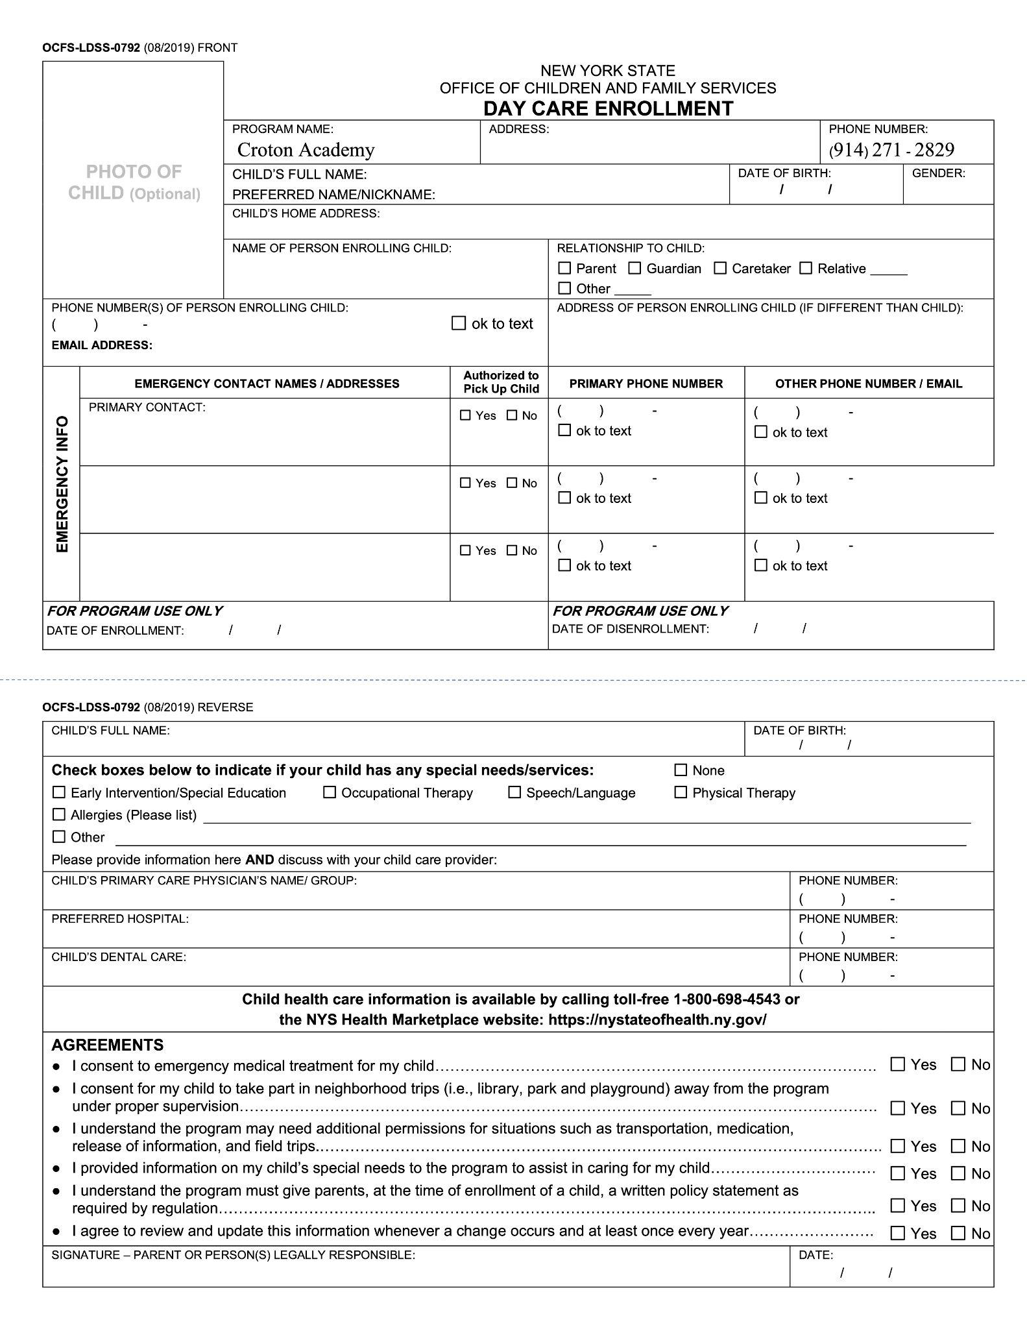

OCFS-LDSS -7006 (07/2022) FRONT
NEW YORK STATE OFFICE OF CHILDREN AND FAMILY SERVICES
INDIVIDUAL HEALTH CARE PLAN FOR A CHILD WITH SPECIAL HEALTH CARE NEEDS

You may use this form or an approved equivalent to document an individual health care plan developed for a child with special health care needs.
A child with a special health care need means a child who has a chronic physical, developmental, behavioral or emotional condition expected to last 12 months or more and who requires health and related services of a type or amount beyond that required by children generally.
Working in collaboration with the child’s parent and child’s health care provider, the program has developed the following health care plan to meet the individual needs of:
CHILD NAME: | CHILD DATE OF BIRTH:  / /
NAME OF THE CHILD’S HEALTH CARE PROVIDER: | ☐ Physician  ☐ Physician Assistant  ☐ Nurse Practitioner
Describe the special health care needs of this child and the plan of care as identified by the parent and the child’s health care provider. This should include information completed on the medical statement at the time of enrollment or information shared post enrollment.
Identify the caregiver(s) who will provide care to this child with special health care needs:
Caregiver’s Name | Credentials or Professional License Information (if applicable)

OCFS-LDSS-7006 (07/2022) REVERSE
NEW YORK STATE OFFICE OF CHILDREN AND FAMILY SERVICES
INDIVIDUAL HEALTH CARE PLAN FOR A CHILD WITH SPECIAL HEALTH CARE NEEDS
Describe any additional training, procedures or competencies the caregiver identified will need to carry out the health care plan for the child with special health care needs as identified by the child’s parent and/or the child’s health care provider. This should include information completed on the medical statement at the time of enrollment or information shared post enrollment. In addition, describe how this additional training and competency will be achieved including who will provide this training.
This plan was developed in close collaboration with the child’s parent and the child’s health care provider. The caregivers identified to provide all treatments and administer medication to the child listed in the specialized individual health care plan are familiar with the child care regulations and have received any additional training needed and have demonstrated competency to administer such treatment and medication in accordance with the plan identified.
PROGRAM NAME: | FACILITY ID NUMBER: | PROGRAM TELEPHONE NUMBER:  ( )
CHILD CARE PROVIDER’S NAME (PLEASE PRINT): |  | DATE:  / /
CHILD CARE PROVIDER’S SIGNATURE:
X
I agree this Individual Health Care Plan meets the needs of my child. Yes ☐ No ☐
I give consent to share information about my child's allergy with all program caregivers in a non-discreet way. I support the strategies the program implements to keep my child from being exposed to known allergen(s). I acknowledge these strategies may include visual reminders that may result in the disclosure of my child's confidential allergy information to non-child care staff. Yes ☐ No ☐
Signature of Parent:
X | DATE:  / /
OCFS-LDSS-0792A (09/2022) FRONT
PHOTO OF CHILD (Optional) |  |  | NEW YORK STATE  OFFICE OF CHILDREN AND FAMILY SERVICES  INDIVIDUAL ALLERGY AND ANAPHYLAXIS EMERGENCY ACTION CARD
 |  |  | CHILD’S FULL NAME: |  | DATE OF BIRTH:  / / |  | GENDER:
 |  |  | KNOWN ALLERGENS: |  |  | ASTHMA?  ☐ YES ☐ NO
HISTORY OF ANAPHYLAXIS?
☐ YES ☐ NO
POTENTIAL SYMPTOMS: |  |  |  | MEDICATION/DOSAGE/LOCATION:
EXPOSURE  ACTION  PLAN | 1.
 | 2.
 | 3.
 | 4.

OCFS-LDSS-0792A (09/2022) REVERSE
RISK MANAGEMENT STRATEGIES:
NOTES:
EMERGENCY CONTACT(S):

PROVIDER SIGNATURE:  X | DATE:  / /
SIGNATURE – PARENT OR PERSON LEGALLY RESPONSIBLE:  X | DATE:  / /

